F-29 – Customer Down (Advance)Payment
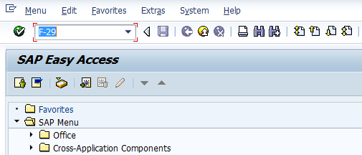
- Input F-29 in Transaction box and press Enter key

Document Header Data Information
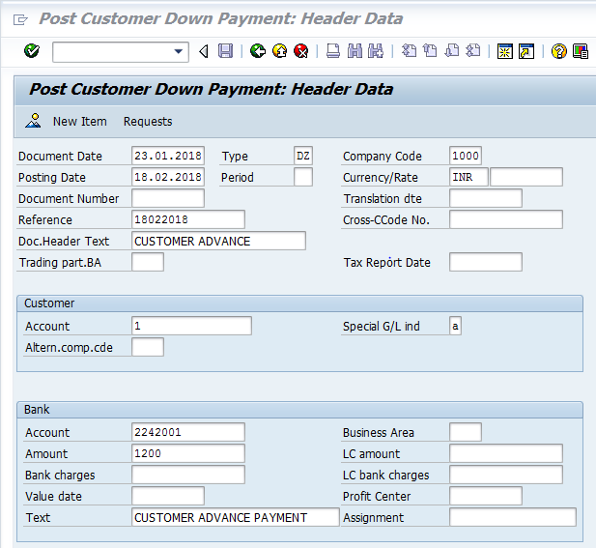
The following are the Input fields under the Document Header data of Vendor Down Payment
- Document Date: Input the Invoice date in the field
- Posting Date: Input the transaction date in the Posting date field
- Document Type: Input the Document type DZ for Customer Down payment
- Company Code: Input the Company code 1000 in this field
- Currency: Input the Currency INR in the Currency field
- Reference: Input the Reference field with Reference (invoice) number
Customer Information: Under the Customer section
- Customer: Input the Vendor Number in this field
- Special G/L ind: Place the cursor on the field and press F4. Down Payment options will appear in a separate window, select the respective option and press Enter key
Bank Data: Under this Section
- Account: Place the cursor on the field and press F4. List of GL Accounts will appear, select respective Bank outgoing GL Account and press Enter key
- Amount: Input the amount
- Profit Center: Input the respective Profit center by selecting from the drop down list
- Text: Input the text information in this field

Document Line Item Data
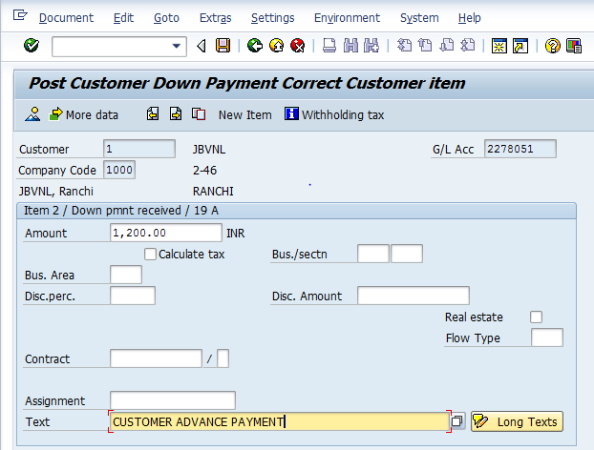

The following are the Input fields under the Line Item data
- Amount: Input the value/amount
- Tax Code: Select the respective code and select calculate tax check box
- Text Field: Input the Text information Eg: Customer Advance Posting
- Profit Center: Place the cursor on the field and press F4. Select respective Profit center and press Enter key

Document Posting
- Click on Post option in the Menu bar
- Document is posted, An information will be populated at the bottom of the screen

Document Display View
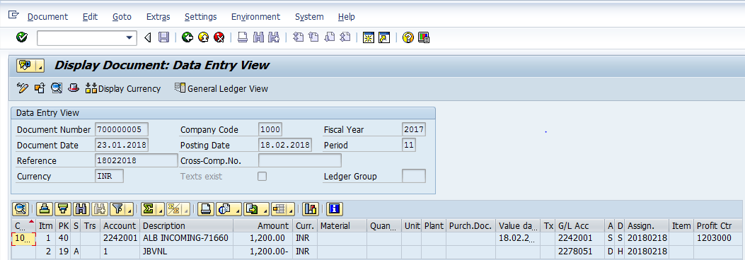
We can view the transaction in two ways:
- Display Document: From Menu bar select Document option it will display the options Change, Display and Other Document. Choose Display option. Document successfully got posted will get displayed
- Input FB03 in Transaction box and system will take us to Document Display screen. Input the Document number and Press Enter key. Document posted will get displayed.

Manual End

